**Task 3 -Gemini**

**CSS Selectors: Targeting Elements**

**CSS Selectors** are patterns used to specify which HTML elements should be affected by a particular CSS rule. They provide a way to target specific elements based on their tags, classes, IDs, attributes, or other characteristics.

**Types of CSS Selectors**

1. **Element Selectors:** Target elements based on their tag name.
   * Example: p { color: blue; } targets all <p> elements.
2. **Class Selectors:** Target elements that have a specific class attribute.
   * Example: .special { font-weight: bold; } targets elements with the class "special".
3. **ID Selectors:** Target a single element with a unique ID attribute.
   * Example: #myHeading { text-align: center; } targets the element with the ID "myHeading".
4. **Attribute Selectors:** Target elements based on their attributes.
   * Example: [href] { color: red; } targets all elements with an href attribute.
5. **Pseudo-Classes:** Target elements based on their state or position.
   * Example: a:hover { background-color: yellow; } targets <a> elements when the mouse hovers over them.

**Example HTML Document with Various Selectors**

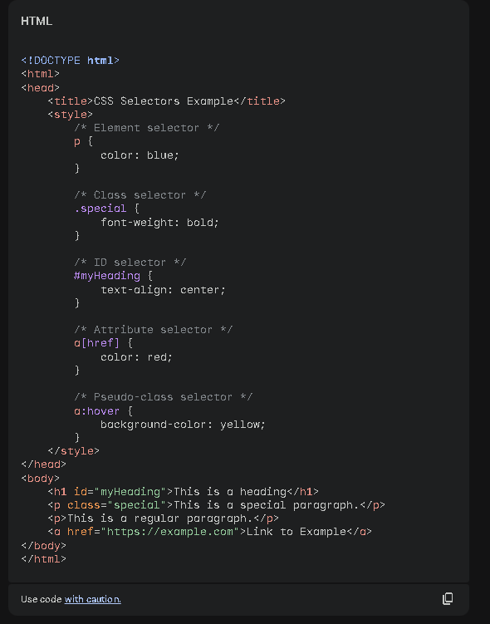

**Explanation of How Selectors Target Elements**

* **Element Selector:** The p selector targets all <p> elements in the document, making their text color blue.
* **Class Selector:** The .special selector targets the <p> element with the class "special", making its font weight bold.
* **ID Selector:** The #myHeading selector targets the <h1> element with the ID "myHeading", centering its text.
* **Attribute Selector:** The a[href] selector targets all <a> elements that have an href attribute, making their text color red.
* **Pseudo-Class Selector:** The a:hover selector targets <a> elements when the mouse hovers over them, changing their background color to yellow.

By understanding and effectively using CSS selectors, you can precisely target and style specific elements in your HTML documents.

**Result**

**Befor hover:**



**Hover:**

